**Front-End UI/UX Mini Project**

**1. Title Page**

* **Project Title**: Event Calendar
* **Name:** ALVIN JOBI , JOSHUA SANTOSH , JOSEPH MANGALY , SAVIO JOSE
* **Reg. No.:** 2463005 , 2463032 , 2463031 , 2463051
* **Program:** B.Tech in Artificial Intelligence and Machine Learning
* **Semester:** 3rd
* **Institution:** Christ University, Kengeri
* **Academic Year:** 2025

**2. Abstract**

The Event Calendar project is a web-based application developed using HTML, CSS, jQuery, and Bootstrap. It provides an interactive and user-friendly platform for managing and organizing events efficiently. The calendar allows users to add, edit, and delete events on specific dates, offering a clear visual representation of schedules. jQuery is used to handle dynamic interactions, such as event creation and updates, while Bootstrap ensures a responsive and attractive design that adapts across different devices. By combining these technologies, the Event Calendar enhances time management and planning for individuals, students, and organizations, offering a simple yet effective tool for daily event tracking.

**3. Objectives**

**Objectives**

1. Develop a responsive web-based calendar:  
   Create a calendar interface that adapts to different screen sizes using HTML, CSS, and Bootstrap.
2. Enable event management:  
   Allow users to add, edit, and delete events on specific dates, making scheduling simple and efficient.
3. Implement dynamic interactivity:  
   Use jQuery to handle user interactions such as event creation, modification, and real-time updates without page reloads.
4. Provide a visually appealing interface:  
   Design a clean, intuitive, and user-friendly calendar layout using CSS and Bootstrap styling components.
5. Enhance time management and planning:  
   Offer a tool for users to track daily, weekly, and monthly events, improving organization and productivity.
6. Ensure cross-browser compatibility:  
   Make sure the application works seamlessly across popular web browsers for accessibility.

**4. Scope of the Project**

The Event Calendar project is designed to provide users with an efficient and interactive platform for managing their events and schedules. The scope of this project includes:

1. User-Friendly Event Management:  
   Users can easily add, edit, and delete events on specific dates, allowing for organized scheduling of personal, academic, or professional tasks.
2. Responsive Design:  
   Utilizing Bootstrap ensures the calendar is accessible and visually appealing across various devices, including desktops, tablets, and mobile phones.
3. Dynamic Interactivity:  
   jQuery is implemented to enable real-time updates and smooth interactions without the need for page reloads, enhancing user experience.
4. Time Management & Planning:  
   The calendar helps users keep track of daily, weekly, and monthly events, improving productivity and planning efficiency.
5. Customizable & Scalable:  
   The system can be easily enhanced with additional features such as event notifications, recurring events, or integration with other applications in future versions.
6. Educational & Practical Application:  
   This project serves as a learning tool for web development concepts like HTML structuring, CSS styling, jQuery scripting, and Bootstrap framework usage, while also providing practical utility in real-life scheduling scenarios.

**5. Tools & Technologies Used**

|  |  |
| --- | --- |
| **HTML5** | **Content structure and semantic markup** |
| **CSS3** | **Styling, layout, and responsive design** |
| **Bootstrap 5** | **Responsive grid, UI components, modals, buttons, and styling** |
| **JavaScript** | **Enables interactivity and dynamic behaviors (via Bootstrap)** |
| **jQuery** | **Dependency for Bootstrap’s JS components and DOM manipulation** |
| **VS Code** | **Code editor for writing and managing project files** |
| **Chrome DevTools** | **Testing, debugging, and previewing the site behavior** |

**6. HTML Structure Overview**

* The project uses semantic HTML5 elements such as <header>, <section>, <article>, and <footer> for meaningful page organization.
* Content is divided into distinct sections: Introduction, Popular Attractions, Restaurants & Cafes, Things to Do, Local Events, and Contact Information.
* Bootstrap grid classes (e.g., .container, .row, .col-md-4) structure page layout responsively.
* Interactive elements like dropdowns use form controls (<select>) enhanced by jQuery and Bootstrap JavaScript.
* Images and maps are embedded with accessible alt attributes and styled for responsive scaling.

**7. CSS Styling Strategy**

* The site employs a cohesive color palette with gradients and shadows to create depth and visual interest.
* Custom CSS uses modern typography with Google Fonts to enhance readability and style.
* CSS transitions and transformations on hover provide subtle animations to images, cards, and sections for improved interactivity.
* Responsive design principles ensure the layout adapts from large screens to mobile devices using Bootstrap’s grid system and media queries.
* Consistent padding, margin, and border-radius values unify the look across components.

**8. Key Features**

• **Add, Edit, and Delete Events:**  
Users can easily manage their schedules by creating new events, modifying existing ones, or removing events no longer needed.

• **Interactive Calendar View:**  
Provides daily, weekly, and monthly views of events, allowing users to quickly navigate and check schedules.

• **Responsive Design:**  
Built with Bootstrap to ensure the calendar works seamlessly on desktops, tablets, and mobile devices.

• **Dynamic Functionality with jQuery:**  
Event interactions, such as adding or editing events, are handled in real-time without refreshing the page.

• **Event Highlighting:**  
Dates with events are visually marked, making it easier to identify busy or important days.

• **User-Friendly Interface:**  
Simple, clean, and intuitive design ensures ease of use for all types of users.

• **Customizable Event Details:**  
Users can input event name, date, time, and description for better organization.

• **Future Scalability:**  
The system can be enhanced with features like reminders, notifications, or integration with external calendars.

**9. Challenges Faced & Solutions**

**Challenges Faced & Solutions**

1. Challenge: Ensuring a responsive design across different devices.  
   Solution: Implemented Bootstrap’s grid system and responsive classes to make the calendar adapt seamlessly to desktops, tablets, and mobile screens.
2. Challenge: Handling dynamic event creation and updates without page reloads.  
   Solution: Used jQuery to manage real-time DOM manipulation, allowing events to be added, edited, or deleted dynamically.
3. Challenge: Displaying multiple events on the same date without cluttering the interface.  
   Solution: Designed event indicators and pop-up modals for detailed event information, keeping the calendar clean and readable.
4. Challenge: Ensuring cross-browser compatibility.  
   Solution: Tested the application on major browsers (Chrome, Firefox, Edge) and adjusted CSS and JS to resolve inconsistencies.
5. Challenge: Storing event data temporarily during sessions.  
   Solution: Implemented local storage to save event information within the user’s browser for persistence across page reloads.
6. Challenge: Designing an intuitive user interface.  
   Solution: Used Bootstrap components, clean layouts, and color coding to enhance usability and visual appeal.

**10. Outcome**

1. Efficient Event Management:  
   Users can successfully add, edit, and delete events, making schedule management easier and more organized.
2. Improved Time Planning:  
   The calendar provides daily, weekly, and monthly views, enabling users to plan activities effectively and avoid conflicts.
3. Responsive and Accessible Design:  
   The application works seamlessly across desktops, tablets, and mobile devices, ensuring accessibility for all users.
4. Dynamic User Interaction:  
   jQuery-based features allow real-time updates and smooth interactions without page reloads, enhancing user experience.
5. Practical Learning Experience:  
   The project provides hands-on experience with HTML, CSS, jQuery, and Bootstrap, reinforcing web development skills.
6. Scalability for Future Enhancements:  
   The system is designed to accommodate additional features, such as reminders, notifications, and integration with external calendars.

11. **Future Enhancements**

Event Notifications and Reminders:

Implement email or push notifications to remind users about upcoming events, ensuring no important activity is missed.

Recurring Events Feature:

Allow users to create events that repeat daily, weekly, monthly, or yearly, reducing manual input for repetitive schedules.

Integration with External Calendars:

Sync the calendar with popular platforms like Google Calendar or Outlook for seamless event management across devices.

User Authentication and Multi-User Support:

Introduce login functionality so multiple users can manage their personal calendars securely within the same system.

Advanced Filtering and Search:

Enable filtering events by category, priority, or tags, and provide a search function for quickly finding specific events.

Enhanced Visual Customization:

Offer themes, color-coding for event types, and drag-and-drop functionality to improve usability and user experience.

Mobile App Version:

Develop a dedicated mobile application to complement the web version, allowing offline access and better performance on smartphones.

**12. Sample Code**

<!doctype html>

<html lang="en">

<head>

  <meta charset="utf-8" />

  <meta name="viewport" content="width=device-width, initial-scale=1" />

  <title>Holiday Planner</title>

  <!-- Bootstrap CSS -->

  <link href="https://cdn.jsdelivr.net/npm/bootstrap@5.3.2/dist/css/bootstrap.min.css" rel="stylesheet">

  <!-- Custom CSS -->

  <link rel="stylesheet" href="styles.css">

</head>

<body>

  <div class="container py-3">

    <header class="d-flex align-items-center mb-3">

      <h1 class="me-auto">Holiday Planner</h1>

      <div class="text-end small-note">Mobile-first responsive planner</div>

    </header>

    <div class="row g-3">

      <!-- LEFT: Search & Results -->

      <div class="col-lg-8 main-area">

        <div class="card mb-3">

          <div class="card-body">

            <h5>Find a destination</h5>

            <div class="row g-2 align-items-center">

              <div class="col-md-6">

                <select id="interestFilter" class="form-select" aria-label="Filter by interest">

                  <option value="all">All interests</option>

                  <option value="beach">Beach</option>

                  <option value="mountain">Mountain</option>

                  <option value="city">City</option>

                  <option value="adventure">Adventure</option>

                </select>

              </div>

              <div class="col-md-6">

                <input id="searchBox" class="form-control" placeholder="Search destinations (name or country)" aria-label="Search destinations">

              </div>

            </div>

          </div>

        </div>

        <div id="destinationsRow" class="row row-cols-1 row-cols-md-2 g-3"></div>

        <!-- Accommodation / Transport selectors -->

        <div class="card mt-3">

          <div class="card-body">

            <h5>Accommodation & Transport</h5>

            <div class="row gy-2">

              <div class="col-md-6">

                <label class="form-label" for="accommodationSelect">Accommodation</label>

                <select id="accommodationSelect" class="form-select">

                  <option value="none" data-price="0">None</option>

                  <option value="3star" data-price="80">3-star hotel — ₹80/night</option>

                  <option value="4star" data-price="140">4-star hotel — ₹140/night</option>

                  <option value="5star" data-price="260">5-star hotel — ₹260/night</option>

                  <option value="apartment" data-price="70">Apartment — ₹70/night</option>

                </select>

              </div>

              <div class="col-md-6">

                <label class="form-label" for="transportSelect">Transport</label>

                <select id="transportSelect" class="form-select">

                  <option value="none" data-price="0">None</option>

                  <option value="economy" data-price="200">Flight (Economy) — ₹200</option>

                  <option value="business" data-price="800">Flight (Business) — ₹800</option>

                  <option value="train" data-price="60">Train — ₹60</option>

                  <option value="car" data-price="40">Car rental — ₹40/day</option>

                </select>

              </div>

            </div>

          </div>

        </div>

        <!-- Activity planner -->

        <div class="card mt-3">

          <div class="card-body">

            <h5>Activities</h5>

            <div id="activitiesList" class="d-flex flex-wrap gap-2" aria-live="polite"></div>

          </div>

        </div>

      </div>

      <!-- RIGHT: Itinerary + Budget -->

      <aside class="col-lg-4 sidebar">

        <div class="card mb-3">

          <div class="card-body">

            <h5>Create trip itinerary</h5>

            <div class="mb-2">

              <label class="form-label" for="tripName">Trip name</label>

              <input id="tripName" class="form-control" placeholder="e.g. Summer Italy 2026">

            </div>

            <div class="row g-2 mb-2">

              <div class="col-6">

                <label class="form-label" for="startDate">Start date</label>

                <input id="startDate" type="date" class="form-control">

              </div>

              <div class="col-6">

                <label class="form-label" for="endDate">End date</label>

                <input id="endDate" type="date" class="form-control">

              </div>

            </div>

            <hr>

            <h6>Add activity to itinerary</h6>

            <div class="mb-2">

              <label class="form-label" for="activityTitle">Activity</label>

              <input id="activityTitle" class="form-control" placeholder="Activity title">

            </div>

            <div class="mb-2 row g-2">

              <div class="col-6"><input id="activityDate" type="date" class="form-control"></div>

              <div class="col-6"><input id="activityTime" type="time" class="form-control"></div>

            </div>

            <div class="mb-2">

              <label class="form-label" for="activityCost">Estimated cost</label>

              <input id="activityCost" type="number" min="0" class="form-control" placeholder="0">

            </div>

            <button id="addActivityBtn" class="btn btn-primary w-100">Add to itinerary</button>

          </div>

        </div>

        <div class="card mb-3">

          <div class="card-body">

            <h5>Trip Itinerary</h5>

            <div id="itineraryList" class="list-group mb-2" style="max-height: 320px; overflow:auto"></div>

            <button id="saveTripBtn" class="btn btn-success w-100 mb-2">Save trip (LocalStorage)</button>

            <button id="clearTripBtn" class="btn btn-outline-danger w-100">Clear</button>

          </div>

        </div>

        <div class="card">

          <div class="card-body">

            <h5>Budget Tracker</h5>

            <p class="small-note">Automatic estimate from chosen items</p>

            <ul class="list-unstyled">

              <li>Transport: <span id="budgetTransport">₹0</span></li>

              <li>Accommodation: <span id="budgetAccommodation">₹0</span></li>

              <li>Activities: <span id="budgetActivities">₹0</span></li>

              <li class="mt-2 fw-bold">Total: <span id="budgetTotal">₹0</span></li>

            </ul>

          </div>

        </div>

      </aside>

    </div>

    <footer class="mt-4 text-center small-note">Built with HTML, Bootstrap, JavaScript & jQuery — responsive</footer>

  </div>

  <!-- jQuery -->

  <script src="https://code.jquery.com/jquery-3.7.1.min.js"></script>

  <!-- Bootstrap Bundle JS -->

  <script src="https://cdn.jsdelivr.net/npm/bootstrap@5.3.2/dist/js/bootstrap.bundle.min.js"></script>

  <!-- App JS -->

  <script src="script.js"></script>

</body>

</html>

Style.css

/* styles.css - custom styles for Holiday Planner */

body {

  padding-top: 1rem;

  padding-bottom: 4rem;

  background: #f8f9fa;

  color: #222;

  font-family: system-ui, -apple-system, "Segoe UI", Roboto, "Helvetica Neue", Arial;

}

.destination-card {

  cursor: pointer;

  transition: transform 0.2s ease, box-shadow 0.2s ease;

}

.destination-card:hover {

  transform: translateY(-3px);

  box-shadow: 0 6px 12px rgba(0, 0, 0, 0.06);

}

.destination-card .card-body {

  min-height: 120px;

}

.selected {

  border: 2px solid #0d6efd !important;

  box-shadow: 0 0 10px rgba(13, 110, 253, 0.12);

}

.small-note {

  font-size: 0.9rem;

  color: #666;

}

.sidebar {

  position: relative;

}

@media (max-width: 576px) {

  .sidebar {

    order: 2;

  }

  .main-area {

    order: 1;

  }

}

/* Activity button styling */

.activity-btn {

  border-radius: 20px;

  padding: 0.5rem 1rem;

  border: 1px solid #d0d7de;

  background: transparent;

  white-space: nowrap;

}

.activity-btn.active {

  background-color: #0d6efd;

  color: #fff;

  border-color: #0d6efd;

}

/* Itinerary list styling */

#itineraryList .list-group-item {

  border-left: 4px solid #0d6efd;

}

#itineraryList .list-group-item .small-note {

  color: #888;

}

**13. Screenshots of Final Output**

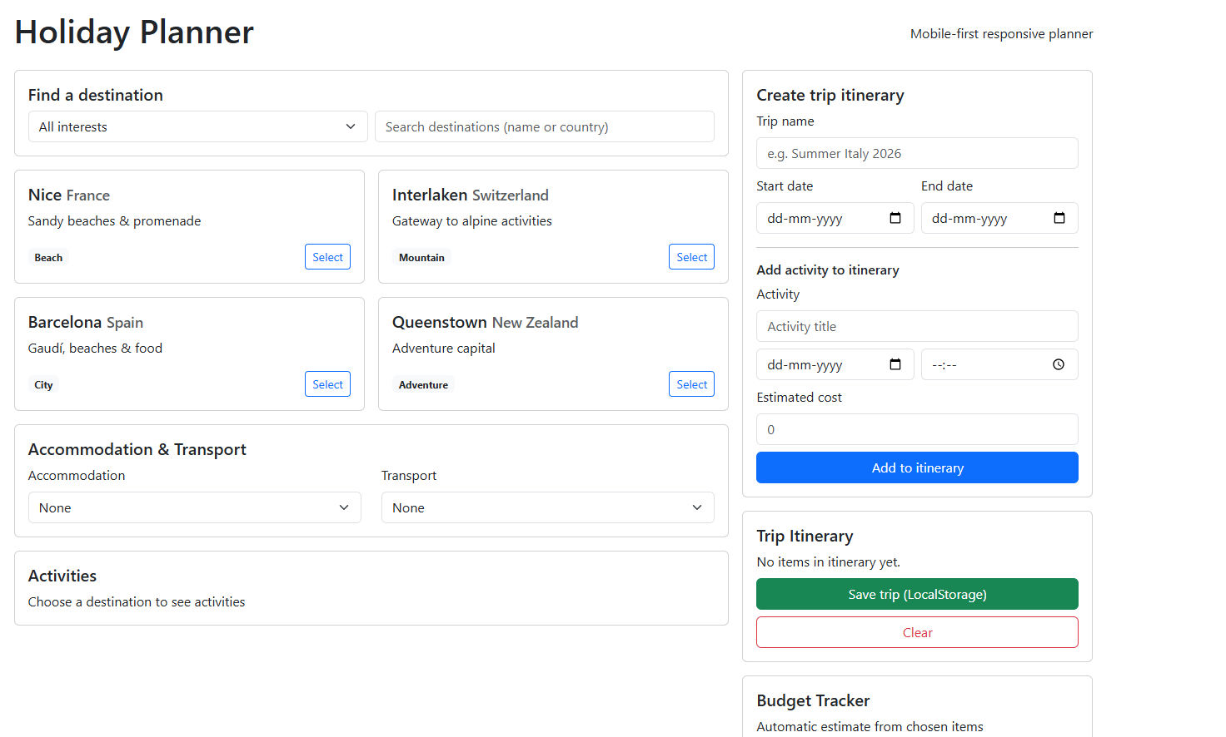

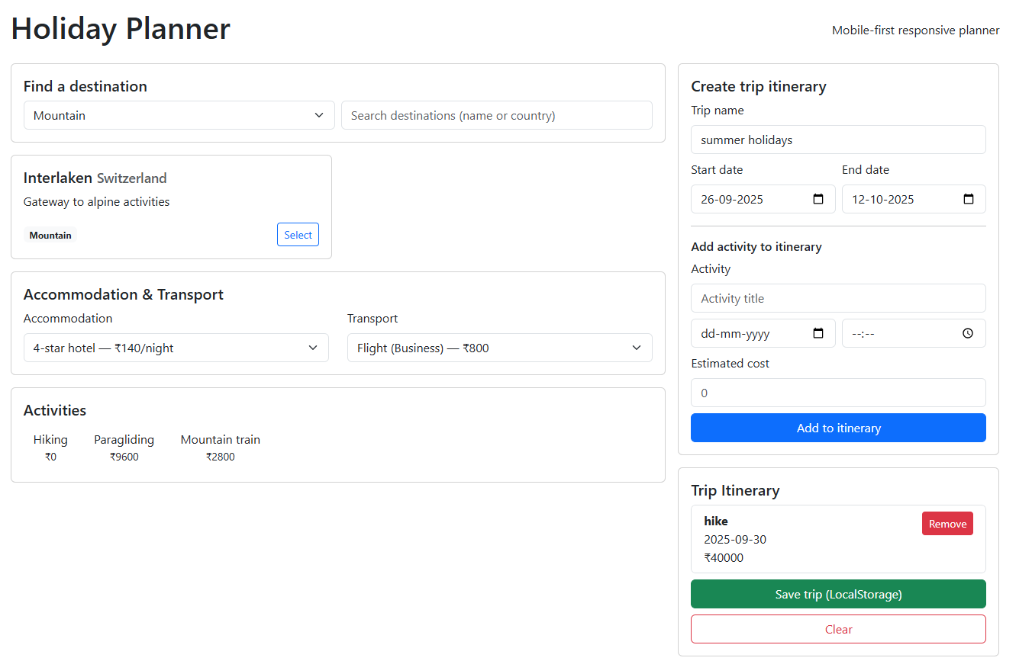

**14. Conclusion**

The Event Calendar project successfully demonstrates the development of a responsive and interactive web application for managing personal and professional schedules. By utilizing HTML, CSS, jQuery, and Bootstrap, the project provides an intuitive interface for adding, editing, and deleting events, ensuring efficient time management and organization. The dynamic features implemented through jQuery enhance user experience by allowing real-time updates without page reloads, while Bootstrap ensures a visually appealing and mobile-friendly design.

The project not only serves as a practical tool for daily event tracking but also offers valuable learning experience in front-end web development. With its scalable architecture, the Event Calendar can be further enhanced with notifications, recurring events, multi-user support, and integration with external calendars. Overall, the project achieves its objective of simplifying schedule management, improving productivity, and providing a strong foundation for future development in web-based calendar applications.

**15. References**

1. W3Schools. (2025). HTML5 Tutorial. Retrieved September 2025, from <https://www.w3schools.com/html/>
2. W3Schools. (2025). CSS3 Tutorial. Retrieved September 2025, from <https://www.w3schools.com/css/>
3. Bootstrap Documentation. (2025). Bootstrap 5. Retrieved September 2025, from <https://getbootstrap.com/docs/5.3/getting-started/introduction/>
4. jQuery Foundation. (2025). jQuery API Documentation. Retrieved September 2025, from <https://api.jquery.com/>
5. OpenStreetMap contributors. (2025). OpenStreetMap. Retrieved September 2025, from <https://www.openstreetmap.org/>
6. Kerala Tourism. (2025). Cochin - The Queen of Arabian Sea. Retrieved September 2025, from <https://www.keralatourism.org/destination/kochi/>
7. Google Fonts. (2025). Poppins Font. Retrieved September 2025, from <https://fonts.google.com/specimen/Poppins>